**TRIGGERS**

**TRIGGER 1:**

**SQL SYNTAX**

CREATE TRIGGER `foodservings` BEFORE INSERT ON `fooditems` FOR EACH ROW

BEGIN

DECLARE msg varchar(255);

IF (NEW.servings<1)

THEN

SET msg=concat('check constraint- servings should not be less than 1 violated as servings in the entry is

',cast(NEW.servings as char));

SIGNAL sqlstate 'CK001' SET message_text=msg;

END IF;

End

**Trigger is created**

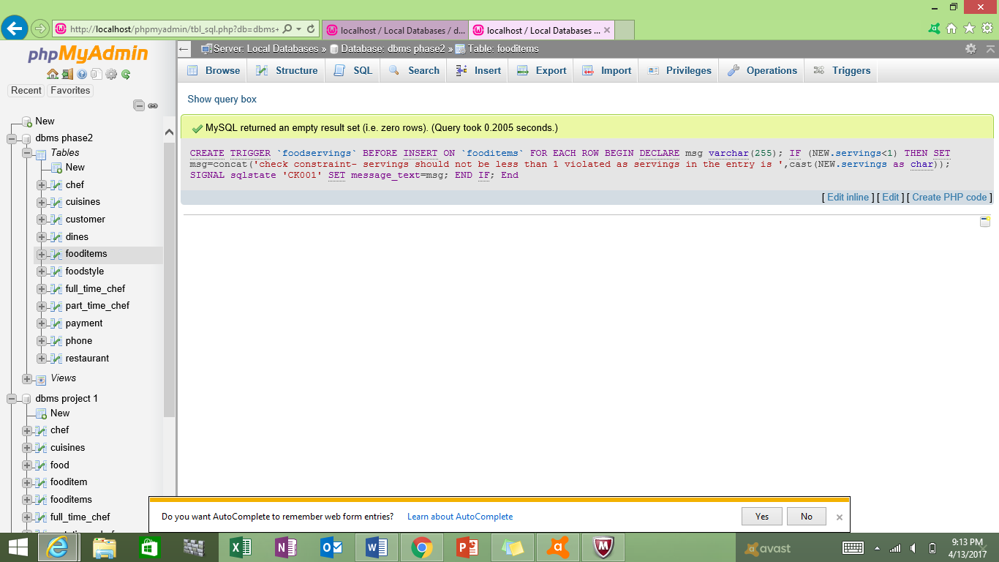

**Trigger Description**

The above trigger is invoked when we try to insert the data into fooditems table. When we try to insert a new record, it checks whether the servings column in the table is greater than 0. If the value of servings is less or equal to zero the new record is not created and an error message is displayed. If the value of servings is greater than 0 then the new record is created successfully.

**Table contents before inserting new record**

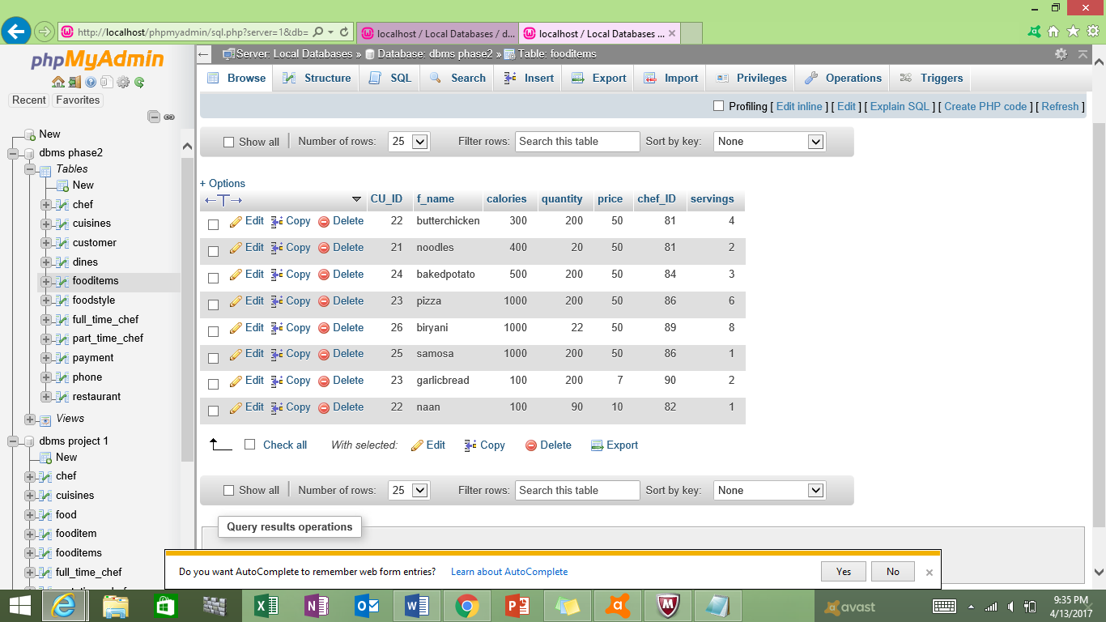

**Insertion of values in the table (new record)**

INSERT into fooditems VALUES(22,'roti',60,150,50,81,0);

**Error message is displayed when the value of servings in the order table is given as 0 (less than 1)**

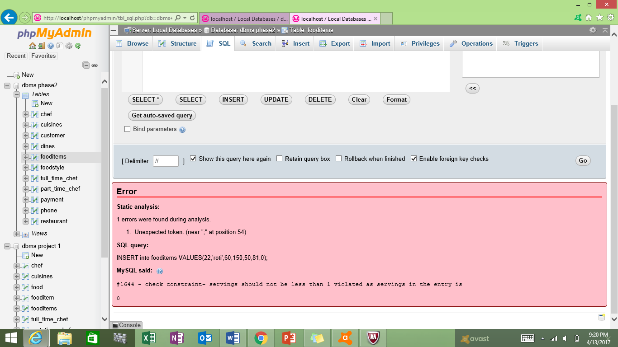

**Insertion of values in the table (new record)**

INSERT INTO fooditems (CU_ID, f_name, calories, quantity,price,chef_ID,servings) VALUES(22,'roti',60,150,50,81,5);

**New record is successfully inserted into the table**

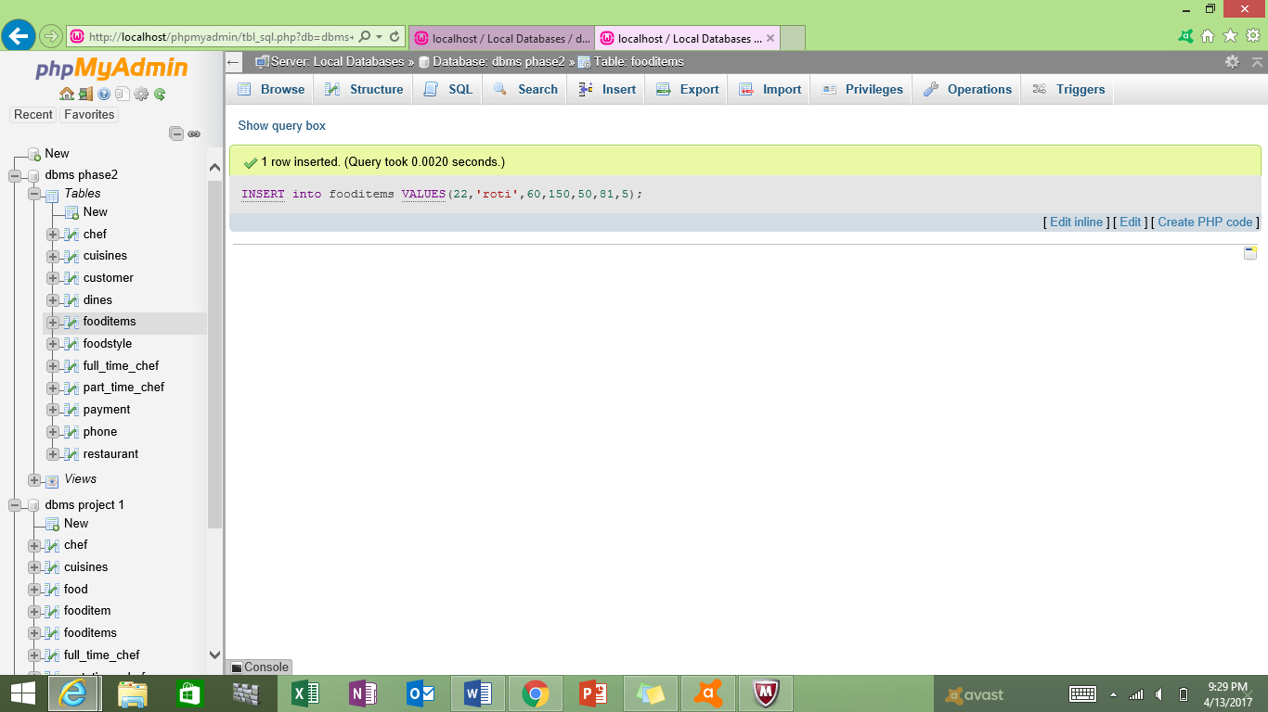

**Table after the insertion of the new record**

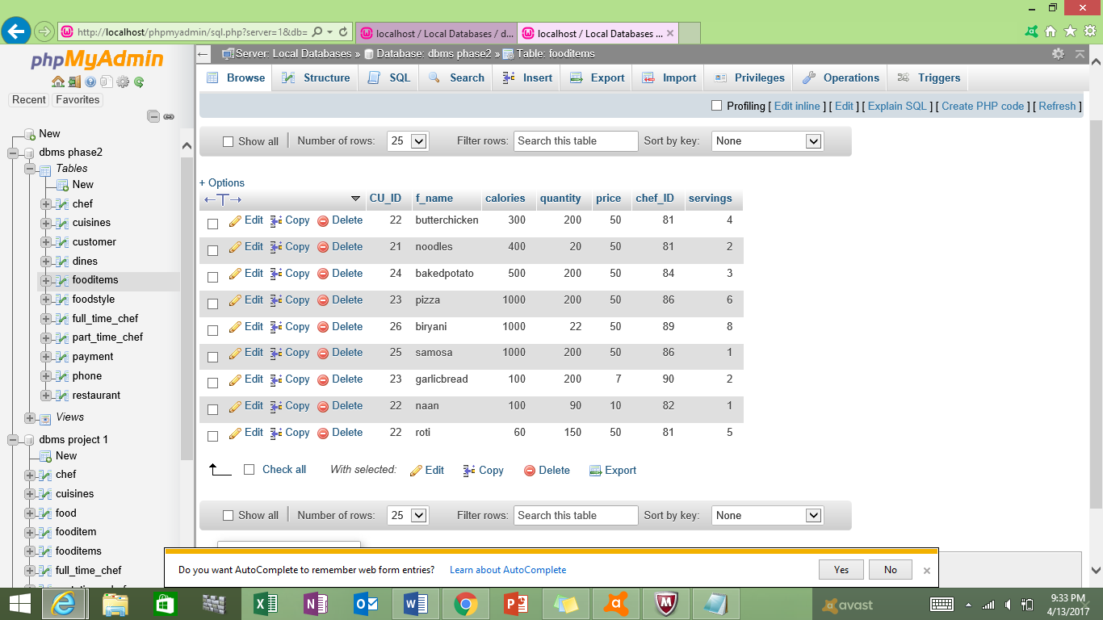

**TRIGGER 2:**

**SQL SYNTAX**

CREATE TRIGGER `fullchefsalary` BEFORE UPDATE ON `full_time_chef` FOR EACH ROW

BEGIN

DECLARE msg varchar(255);

IF (NEW.monthly_salary<2000)

THEN

SET msg=concat('check constraint- servings should not be less than 1 violated as servings in the entry is

',cast(NEW.monthly_salary as char));

SIGNAL sqlstate 'CK001' SET message_text=msg;

END IF;

End

**Trigger is created**

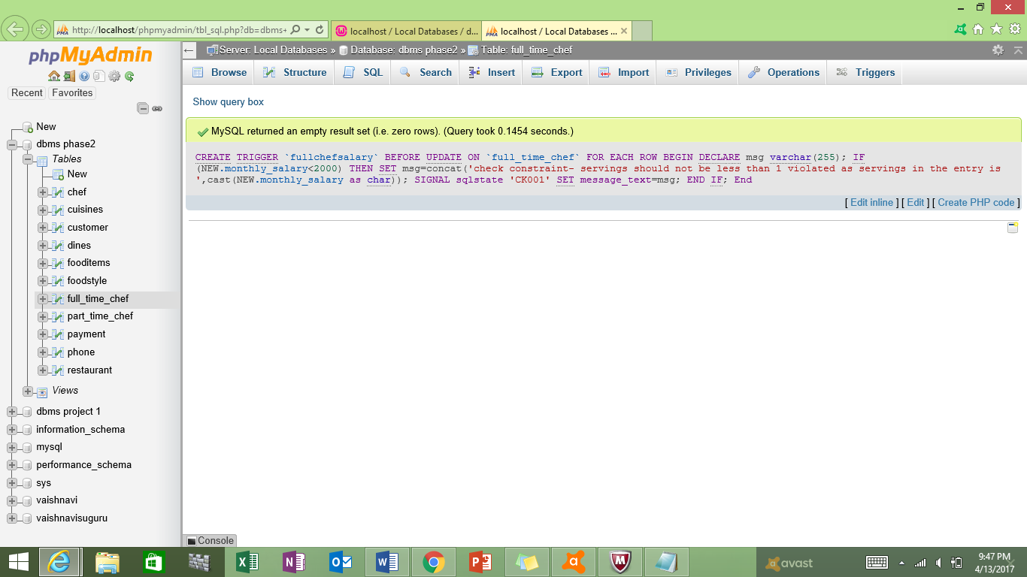

**Trigger Description**

The above trigger is invoked when we try to update the data of full_time_chef table. When we try to update a record, it checks whether the monthly_salary column in the table is greater than 2000. If the value of monthly_salary is less or equal to 2000 then we cannot update the record and an error message is displayed. If the value of monthly_salary is greater than 2000 then the record is updated successfully.

**Table contents before updating the record**

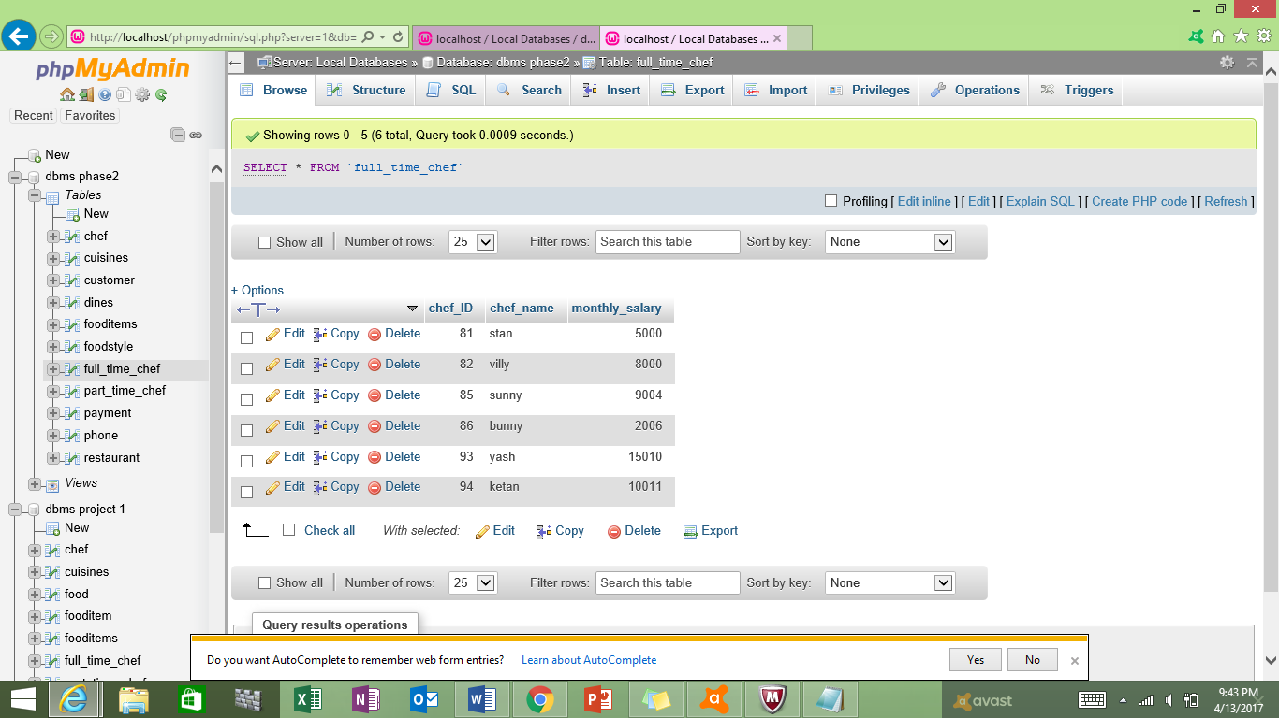

**Updation of values in the table**

UPDATE full_time_chef

set monthly_salary=1000

WHERE chef_ID=81;

**Error message is displayed when the value of monthly_salary in the order table is given as 1000 (less than 2000)**

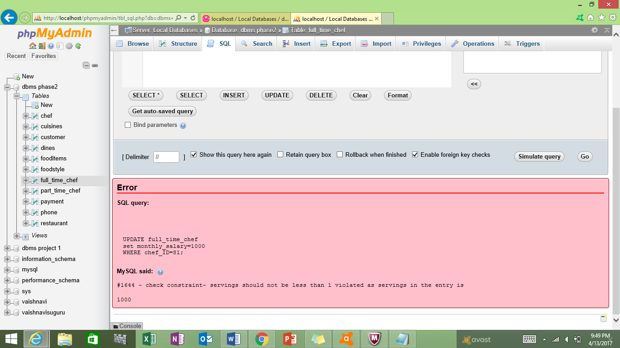

**Updation of values in the table**

UPDATE full_time_chef

set monthly_salary=9999

WHERE chef_ID=81;

**Record is successfully updated into the table**

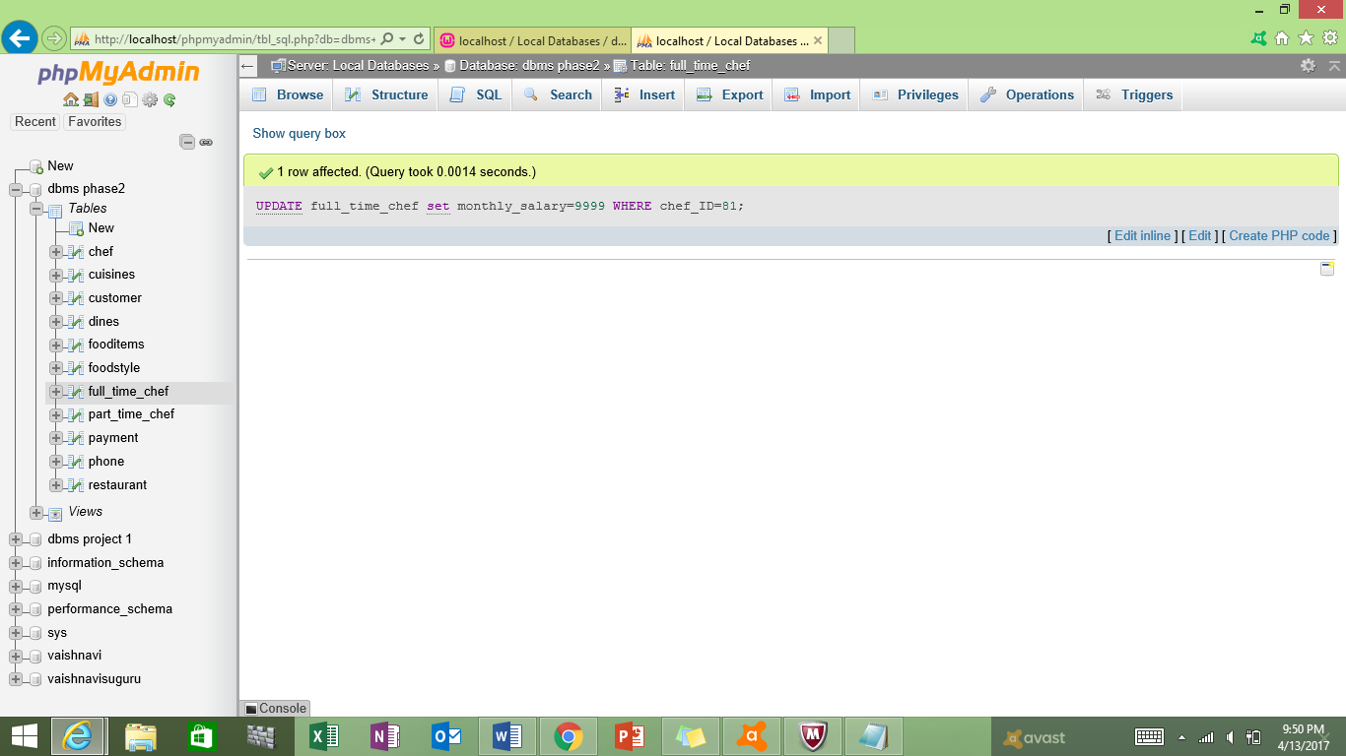

**Table after the updation of the record**

